CHAPTER -6

FLUID DYNAMICS

A branch of physics which deals with the study of flowing fluids is called fluid dynamics.

Drag force:

An object moving through a fluid experiences a retarding force called drag force. The drag force increases by increasing the speed of the object.

The drag force on a sphere of radius ‘r’ moving with speed ‘v’ through a viscous fluid of viscosity ‘ $η$’ is given by

$$F_{D}=6πηrv$$

Note:

At very high speed the drag force no longer remains proportional to speed of object.

Viscosity:

The frictional effect between different layers of a flowing fluid is known as viscosity of the fluid.

Co-efficient of viscosity:

Co-efficient of viscosity of a liquid is defined as the tangential force per unit area required to maintain a unit relative velocity between its two layers through a unit distance.

$$η= \frac{F×d}{A×v}$$

It is denoted by η. Its SI unit is kgm-1s-1 and dimensions are [ML-1T-1].

Stoke`s law:

It states that the drag force $F_{D}$ on a sphere of radius `r` moving slowly with velocity ‘v’ in a fluid of viscosity `η` is given by the following relation

$$F_{D}=6πηrv$$

At high speeds, the force is no longer proportional to speed.

Terminal velocity:

Definition:

When the weight of the falling body and drag force becomes equal in magnitude, the velocity of the body becomes maximum and does not increasefurther. This maximum velocity is called terminal velocity.It is denoted by ‘vt’.

Derivation:

Consider a water droplet such as that of fog falling vertically, the air drag on the water droplet increases with speed. The droplet accelerates rapidly under the action of gravity. However, the upward drag force on it increases as the speed of the droplet increases. The net force on the droplet is

Net force = Weight – Drag force

As the speed of the droplet continues to increase, the air drag eventually approaches the weight of the droplet so that the net force on the droplet becomes zero and the droplet falls with constant velocity. This maximum constant velocity is called terminal velocity.

According to stokes law

$$F_{D}=6πηrv$$

When $F_{D}= mg,$

then

$$v= v_{t}$$

So

m*g* = 6*πηr*vt------ (1)

The density of the droplet is

ρ = $\frac{m}{V}$

$$⟹ m= ρV$$

ButV = *πr3*

Therefore m = *πr3ρ*

Putting value of m in equation (1)

*πr3ρg* = 6*πηr*vt

vt =

vt =

Fluid:

Fluid is a substance which has ability to flow. The examples of fluids are all gases and all liquids.

Fluid flow:

Motion of the fluid is termed as fluid flow.When a fluid is in motion, its flow can be either streamline or turbulent.

Streamline flow:

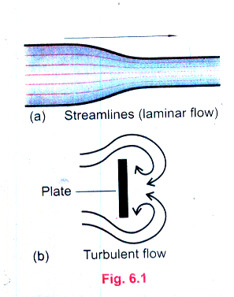The flow is said to be streamline or laminar, if every particle that passes a particular point moves along exactly the same path, as followed by particles which passed that point earlier.

For example:

Flow of water in wide and smooth river surface.

Flow of gentle breeze.

Flow of wind around streamlined designed car.

Turbulent flow:

The irregular or unsteady flow of the fluid is called turbulent flow.

For example:

Flow of water from the top of mountains.

Flow of water in the form of water fall.

Very strongly flowing wind.

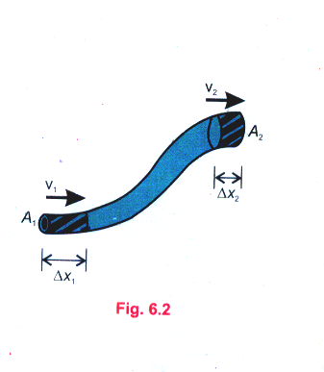Conditions for an ideal fluid:

1. The fluid is non-viscous.
2. The fluid is incompressible.
3. The fluid motion is steady.

Equation of continuity:

Statement:

The product of cross-sectional area of the pipe and the fluid speed at any point along the pipe is a constant. This constant equals the volume flow per second of the fluid or simply flow rate.

Mathematical form:

$$A_{1}v_{1}= A_{2}v_{2}$$

Derivation:

Consider the flow of a fluid through a pipe of non-uniform size as shown in the figure.

The particles in the fluid move along the streamline in a steady state flow as shown in the fig.

At lower end of the pipe:

Let

$A_{1}$ = cross-sectional area of the pipe at lower end.

$v_{1}$ = speed of the fluid at lower end of the pipe.

${∆x}_{1}$ = distance covered by the fluid in short time interval `∆t`.

Applying eq

S= vt

We can write,

$${∆x}_{1}= v_{1}∆t$$

As $density=\frac{mass}{volume}$

Or

$$ρ=\frac{∆m_{1}}{V_{1}}$$

$$⟹ ∆m_{1}= V_{1}× ρ ------(1)$$

As

$$V_{1}=A_{1}l$$

$$V_{1}=A_{1}∆x_{1}$$

$$V_{1}=A_{1}v_{1}∆t$$

Put in equation (1)

$$∆m_{1}=A_{1}v_{1}∆t ρ ------(2)$$

At upper end of pipe:

Let

A2 = cross-sectional area of pipe at upper end of pipe.

∆x2 = distance covered by the fluid in time interval ∆t.

$v_{2}$ = speed of the fluid at upper end of the pipe.

Now for upper end of the pipe

$${∆m}_{2}=A_{2}v_{2}∆tρ -------(3)$$

Now

According to law of conservation of mass

$$∆m_{1}= {∆m}_{2}$$

$$A_{1}v_{1}∆t ρ= A_{2}v_{2}∆tρ$$

$$A_{1}v_{1}= A_{2}v_{2}$$

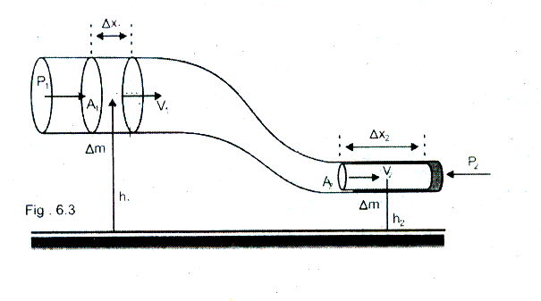

Bernoulli’s equation:

Statement:

The sum of pressure, kinetic energy per unit volume and potential energy per unit volume for a non-viscous and incompressible fluid having steady flow is always constant.

Mathematical form:

$$P_{1}+\frac{1}{2}ρv_{1}^{2}+ρgh_{1}= P_{2}+\frac{1}{2}ρv_{2}^{2}+ρgh_{2}$$

$$P+\frac{1}{2}ρv^{2}+ρgh=constant$$

Derivation:

Let us consider a non-viscous and incompressible fluid having steady flow through a pipe of non-uniform size, in time t, as shown in the figure.

At upper end of the pipe:

Let

$A_{1}$ = cross-sectional area of the pipe at upper end

$v_{1}$ = speed of the fluid at upper end of the pipe

${∆x}_{1}$ = distance covered in short time interval t

$h_{1}$ = average height from the ground level.

P1 = pressure at upper end

Now the force of the fluid is given as

$$F_{1}=P_{1}A_{1}$$

The work done on the fluid, by the fluid behind it, in moving through a distance ∆x1 will be

At lower end of the pipe:

Let

A2 = cross-sectional area of the pipe at lower end.

$v_{2}$ = speed of the pipe at lower end.

${∆x}_{2}$ = distance covered by the fluid in same short time interval t.

h2 = average height from the ground level.

P2 = pressure at lower end.

The work done on the fluid at the lower end is

$$W_{2}=-F_{2}{∆x}_{2}=-P_{2}A_{2}{∆x}_{2}$$

Here negative sign shows that work is done against the fluid force.

Net work done:

Net work done = $W=W_{1}+W_{2}$

$$W=P_{1}A_{1}v_{1}t+\left(-P_{2}A_{2}v_{2}t\right)$$

$$W=P_{1}A_{1}v_{1}t-P_{2}A_{2}v_{2}t-----(1)$$

Now according to equation of continuity

$$A_{1}v_{1}=A_{2}v_{2}=\frac{v}{t}=flow rate$$

$A_{1}v_{1}t=A_{2}v_{2}t$ =V

Put in equation (1)

$$W=P_{1}V-P_{2}V$$

$$W=V\left(P_{1}-P_{2}\right)$$

As

$ρ=\frac{m}{V}$ or $V=\frac{m}{ρ}$

$$therefore W=\frac{m}{ρ}\left(P_{1}-P_{2}\right)$$

Total energy:

As total energy is given as

$$E_{T}=△K.E+△P.E$$

Where

$$△K.E=\frac{1}{2}mv_{2}^{2}-\frac{1}{2}mv_{1}^{2}$$

&

$$△P.E=mgh_{2}-mgh_{1}$$

So

$$E_{T}=\frac{1}{2}mv_{2}^{2}-\frac{1}{2}mv_{1}^{2}+ mgh_{2}-mgh_{1}$$

Here $E_{T}=△K.E+△P.E$ means that the part of work done is utilized by the fluid in changing it’s K.E and the remaining part is used in changing it’s gravitational potential energy.

Law of conservation of energy:

According to law of conservation of energy (or work-energy principle)

$$W=E_{T}$$

$$\frac{m}{ρ}\left(P_{1}-P_{2}\right)=\frac{1}{2}mv_{2}^{2}-\frac{1}{2}mv_{1}^{2}+ mgh_{2}-mgh_{1}$$

$$m\left(P_{1}-P_{2}\right)=ρm\left(\frac{1}{2}v_{2}^{2}-\frac{1}{2}v_{1}^{2}+gh_{2}-gh_{1}\right)$$

$$P_{1}-P_{2}=ρ\left(\frac{1}{2}v_{2}^{2}-\frac{1}{2}v_{1}^{2}+gh_{2}-gh_{1}\right)$$

$$P_{1}-P_{2}=\frac{1}{2}ρv_{2}^{2}-\frac{1}{2}ρv_{1}^{2}+ρgh_{2}-ρgh_{1}$$

$$P_{1}+\frac{1}{2}ρv_{1}^{2}+ρgh_{1}= P_{2}+\frac{1}{2}ρv_{2}^{2}+ρgh_{2}$$

Or $P+\frac{1}{2}ρv^{2}+ρgh=constant$

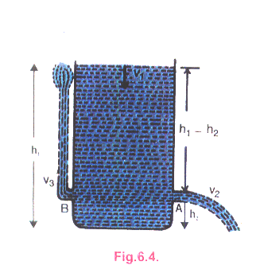

Applications of Bernoulli’s equation:

1. Torricelli’s theorem:

Statement:

The speed of efflux is equal to the velocity gained by the fluid in moving through a distance $h_{1}-h_{2}$ under the action of gravity.

Derivation:

According to Bernoulli’s equation

$$P_{1}+\frac{1}{2}ρv_{1}^{2}+ρgh_{1}= P_{2}+\frac{1}{2}ρv_{2}^{2}+ρgh_{2}$$

But $P_{1}=P_{2}=atmospheric pressure$

So

$$\frac{1}{2}ρv_{1}^{2}+ρgh_{1}=\frac{1}{2}ρv_{2}^{2}+ρgh_{2}------(1)$$

According to equation of continuity

$$A_{1}v_{1}= A_{2}v_{2}$$

$$v_{1}=\frac{A_{2}}{A_{1}}v_{2}$$

As the orifice is very small so $A_{1}≫A_{2}$ and $v_{1}≪v_{2}$ i.e $v_{1}≈0$

So equation (1) becomes

$$ρgh_{1}=\frac{1}{2}ρv_{2}^{2}+ρgh_{2}$$

$$ρg\left(h_{1}-h_{2}\right)=\frac{1}{2}ρv_{2}^{2}$$

$$v_{2}=\sqrt{2g(h_{1}-h_{2})}$$

$$v_{2}=\sqrt{2gΔh}$$

1. Relation between speed and pressure of the fluid:

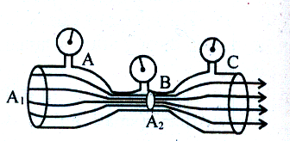 Statement:

Where the speed is high, the pressure will be low.

Proof:

Let’s consider a pipe system through which water flows, as shown in the figure.

According to Bernoulli’s equation

$$P_{A}+\frac{1}{2}ρv_{A}^{2}+ρgh_{A}=P_{B}+\frac{1}{2}ρv_{B}^{2}+ρgh_{B}$$

At average height

$$ρgh_{A}=ρgh_{B}$$

$$P_{A}+\frac{1}{2}ρv_{A}^{2}=P_{B}+\frac{1}{2}ρv_{B}^{2}-------(1)$$

Let $v_{A}=0.20 ms^{-1}$

$${ v}_{B}=2.0 ms^{-1}$$

Density of water = $ρ$ = 1000 $kgm^{-3}$

So equation (1) implies that

$$P_{A}-P_{B}=\frac{1}{2}ρv_{B}^{2}-\frac{1}{2}ρv_{A}^{2}$$

$$P_{A}-P_{B}=\frac{1}{2}ρ\left(v_{B}^{2}-v_{A}^{2}\right)$$

$$P_{A}-P_{B}=\frac{1}{2}×1000\left[{\left(2\right)}^{2}+{\left(0.20\right)}^{2}\right]$$

$$P_{A}-P_{B}=1980 Nm^{-2}$$

$⇒ P_{A}>P_{B}$ Where $V_{A}<V_{B}$

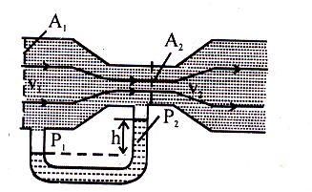Venturi relation:

If one of the pipes has much smaller radius than the other, as shown in the figure, we write the Bernoulli’s equation in a more convenient form. It is assumed that the pipes are horizontal so that $ρgh$ terms become equal and can therefore be dropped. Then

$$P_{1}-P_{2}=\frac{1}{2}ρv_{2}^{2}-\frac{1}{2}ρv_{1}^{2}=\frac{1}{2}ρ\left(v_{2}^{2}-v_{1}^{2}\right)$$

As the cross-sectional area $A_{2}$ is small as compared toarea $A_{1}$,

so from equation of continuity,

$v_{1}=\frac{A_{2}}{A_{1}}v_{2}$,

will be small as compared to $v_{2}.$ So we can neglect $v_{1}$ for flow from large pipe to small pipe.

Hence

$$P_{1}-P_{2}=\frac{1}{2}ρv_{2}^{2}$$

This is known as venturi relation.

Blood flow:

**What type of fluid is blood?**

Blood is an incompressible fluid having density nearly that of water. A high concentration (~50%) of red blood cells increases viscosity from three to five times that of water.

Blood vessels:

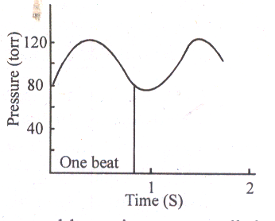Blood vessels are not rigid. They stretch like a rubber hose. Under certain circumstances the volume of the blood is sufficient to keep the vessels inflated at all times, even in the relaxed state between heart beats. This means there is tension in the walls of the blood vessels and consequently the pressure of blood is greater than the external atmospheric pressure.

Variation in blood pressure:

The blood pressure varies from a high systolic pressure of 120 torr to a low diastolic pressure of about 75-80 torr. The numbers tend to increase with age, corresponding to the decrease in flexibility of the vessel walls.

Measurement of blood pressure:

An inflatable bag is wound around the arm of a patient and external pressure on the arm is increased by inflating the bag. The effect is to squeeze the arm and compress the blood vessel inside. When the external pressure applied becomes larger than the systolic pressure, the

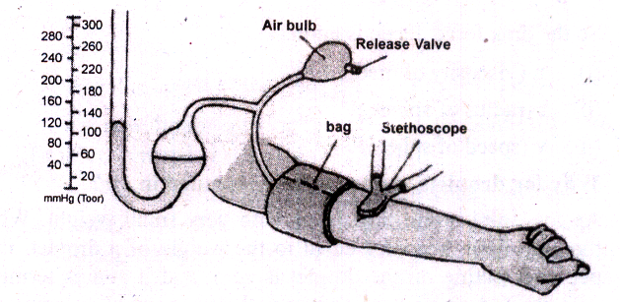vessel collapse, cutting off the flow of the blood. Opening the release valve on the bag gradually decreases the external pressure. A stethoscope detects the instant at which the external pressure becomes equal to the systolic pressure. As the pressure drops, the external pressure eventually equals the diastolic pressure. From this point, the vessel no longer collapse during any portion of the flow cycle. The flow switches from turbulent to laminar. This is the signal to record diastolic pressure.

Short questions

* 1. Explain what do you understand by the term viscosity?

Ans. The property of fluids due to which they oppose relative motion between their different layers is called viscosity. Viscosity of a material is described by a constant $η$ called coefficient of viscosity.

Since

* 1. What is meant by drag force? What are the factors upon which the drag force acting upon a small sphere of radius ‘r’, moving down through a liquid, depend?

Ans. An object through a fluid experiences a retarding force called a drag force. The drag force $F_{D}$ on a sphere of radius ‘r’ moving slowly with a speed ‘v’ through fluid of viscosity ‘η’ is given by stoke’s law, as

$$F_{D}=6πηrv$$

So, the drag force depends upon viscosity of medium, radius of sphere and speed of sphere.

* 1. Why fog droplet appears to be suspended in air?

Ans. When the drag force becomes equal to the weight of droplet, then net force acting on the droplet is zero. So the fog droplet appears to be suspended in air, because of very minute value of terminal velocity given by

$$v_{t}=\frac{mg}{6πηr}$$

This equation shows that terminal velocity ${'v}_{t}'$ depends upon weight ‘mg’. As the weight of the droplet is negligibly small, therefore the terminal velocity is so small that the fog droplet appears to be suspended in air

* 1. Explain the difference between laminar flow and turbulent flow?

Ans. Laminar flow:

1. A regular or steady flow is known as laminar flow.
2. All the particles passing through a specific point have same velocities.
3. Direction of flow of particles is always along the direction of overall flow of fluid.
4. Examples:

Flow of water in wide, Smooth River.

Flow of gentle breeze.

Turbulent flow:

1. An irregular or unsteady flow is known as turbulent flow.
2. All the particles passing through a specific point do not have same velocities.
3. Direction of flow of particles is not along the direction of overall flow of fluid.
4. Examples:

Flow of water from the top of mountains.

Flow of water in the form of a waterfall.

* 1. State Bernoulli’s relation for a liquid in motion and describe some of its applications?

Ans. Bernoulli’s equation states that the sum of pressure, kinetic energy per unit volume and potential energy per unit volume is a constant.

Mathematically,

$$P+\frac{1}{2}ρv^{2}+ρgh=constant$$

Applications:

1. Torricelli’s theorem.
$$v=\sqrt{2g\left(h_{1}-h_{2}\right)}$$

2. Relation between velocity and pressure.
$$P+\frac{1}{2}ρv^{2}=constant$$

3. Venturi relation.
 $$v=\sqrt{\frac{2(P_{1}-P_{2})}{ρ}}$$

  1. A person is standing near a train. Is there any danger that he will fall towards it?

Ans. Yes, due to fast speed of train, air between the person and the train will also be moving with high speed and have less pressure as compared to the pressure on the other side of the person. So, a person may experience a push from high pressure region to low pressure region which may cause him to fall towards the train.

* 1. Identify the correct answer. What do you infer Bernoulli’s theorem?

1. Where the speed of fluid is high the pressure is low.
2. Where the speed of fluid is high the pressure will be high.
3. This theorem is valid only for turbulent flow of the liquid.

Ans. Option ‘i’ is correct.

(Where the speed of fluid is high the pressure is low).



* 1. Two row boats moving parallel in the same direction are pulled towards each other. Explain?

Ans. When two row boats move parallel to each other, the velocity between the boats becomes higher due to which the pressure between them decreases than on the other sides. So boats experience a push from higher pressure to lower pressure which may cause them to pull towards each other.

* 1. Explain how the swing is produced in a fast moving cricket ball?



Ans. During the motion of a spinning ball, the spin motion strengthens the motion of air on one side and cancels the motion of wind on the other side. This causes the difference in pressures which results into a force from high pressure to low pressure thus changing the straight line motion of a ball into a curved one.

* 1. 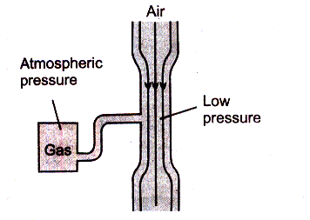Explain the working of carburettor of a motor car using Bernoulli’s principle?

Ans. The carburettor of a car uses a venturi duct which feeds the correct mixture of air and petrol to the cylinders. Air is drawn through duct and along a pipe to the cylinders. A tiny inlet at the side of duct is fed with petrol. The air through duct moves with a greater speed, producing low pressure in the duct. So petrol is pushed along the air stream in the form of vapours.

* 1. For which position will the maximum blood pressure in body have the smallest value? (a) standing up (b) sitting (c) lying horizontally (d) standing on one’s head

Ans. (c) lying horizontally.

* 1. In an orbiting space station, would the blood pressure in major arteries in the leg ever be greater than the B.P in the major arteries in the neck?

Ans. No, there will be no change in blood pressure in major arteries in the leg as well as in the neck, due to weightlessness in orbiting space station.